 WELCOME

Thank you for your interest in my services. I look forward to working with you. This document includes information pertaining to therapy, assessment, directions, parking, office polices, and forms.

Therapy Services:
Therapeutic services typically begin with a 90 minute introductory and information session that involves gathering information and deciding if therapy is the best option. On-going sessions are typically scheduled for weekly, 50-minute sessions. It is often difficult to predict the duration of treatment or number of sessions needed, therefore a treatment plan can be modified to meet specific needs and reviewed every 6 to 8 sessions.

Brief Assessment & Collateral:
Answering brief questionnaires about our experience can be helpful to chart our progress through therapy and our lives. For this reason short forms may be given before and/or after sessions. Contacting collaterals with your permission, such as family & loved ones, can be helpful for us to get a fuller picture of how we are doing.

Forms:
1. Client Intake: Please complete the attached “Client Intake” form. This form is a pdf or word form that can be completed on your computer by simply typing in the spaces provided. The form can be saved and returned to me via Google Drive, email, snail mail, fax, or in-person. **It is very important to complete and send this form PRIOR TO YOUR FIRST APPOINTMENT VISIT or BRING WITH YOU ON THE FIRST OFFICE APPOINTMENT.
2. Consent Form: Please review the “Consent to Treat” form. I will review the form at the initial session with you, answer any questions, and have you sign and date the consent form. I will provide the witness signature.
3. HIPPA Policies: Please carefully review the HIPPA policies. I will review the HIPPA policies at the initial session with you, answer questions, and have you sign and date the consent form. I will provide the witness signature.
4. Authorization for Release of Information: This optional form is a release form that authorizes me to communicate with and provide information to parties you specify (e.g., parent, partner, physician). I will discuss this more in person during the intake and therapy sessions.

Directions
San Francisco Office:
1730 Divisadero St (near Bush)
San Francisco, CA 94115
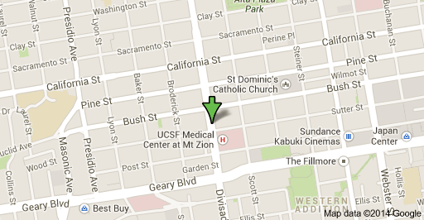

The office is located in the Lower Pacific Heights District of San Francisco near UCSF Medical Center at Mt Zion. The front door is white and without a sign and near the Starbucks at the corner of Divisadero and Bush. Typically, clients enter the passcode and walk up the stairs down the hall and sit in the waiting room. Sometimes before the first session I will meet clients outside of the front door.

Parking San Francisco Office:
- Street Parking: There is 2-hour metered street parking available. The “Pay by Phone” app can be used to link a credit card to easily pay for meters. Time can be added to the meter remotely.
- Garage Parking: For ease of parking, 2300 Sutter Street Garage is close and relatively inexpensive..

Office Policies:
Fee Policies: I do not participate in any managed care networks but many insurance plans offer coverage for the services of a licensed clinical psychologist. Please check with your insurance company to see whether reimbursement may be an option for you. Full payment of the fee is ultimately your responsibility. I am able to provide you with a monthly statement that you can submit to your insurance company should you choose to seek reimbursement from your insurance company. Insurance companies may require the following information: the diagnosis, type of service, date of sessions, and fee. You are responsible for collecting reimbursement from your insurance company.

Fees:
Initial 90 minute intake……………………………………………………………………………..$150.00
50-minute Individual Therapy session……………………………………………………….$100.00
Neuropsychological Assessment and Report Writing hourly rate. …………........$220.00

Payment:
Payment is due in full at the time of the appointment. Payment can be made via check payable to Dr Knute Ayhens-Johnson, or cash.
Please note the final payment for completed neuropsychological reports is due upon completion of the report.

Cancellations:
To maintain the patient focused integrity of my practice, I attempt to accommodate schedules as best as possible. Therefore, if you are unable to keep an appointment, please cancel appointments 48 hours in advance or you will be charged half of the fee for the session. Cancellations can be made via email or phone.

Please do not hesitate to contact me with any questions.
Sincerely,
Dr. Knute
KnutePhD@gmail.com
(415) 418-7215

